2520. Count the Digits That Divide a Number

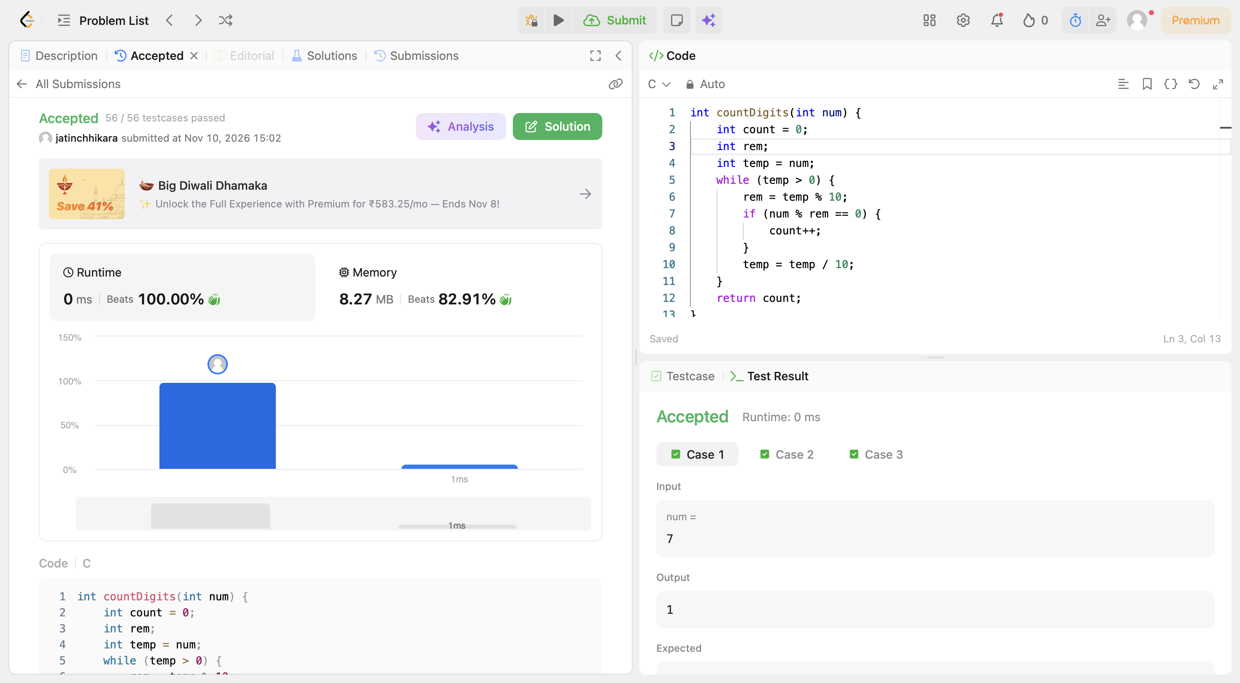
Code:
int countDigits(int num) {
int count = 0;
int rem;
int temp = num;
while (temp > 0) {
rem = temp % 10;
if (num % rem == 0) {
count++;
}
temp = temp / 10;
}
return count;
}

